

Name/ID : ABDELKAREEM YOUSEF MAMDOH SOUBAR/19110022
Subject : Networking
Assignment Title :J-Games
Submission Date : 15/6/2022

network types
  - Local Area Network (LAN)
Local Area Network is the most common network type of all and it’s basically connecting a group of computer together in a short distance/ the covered distance and its usually used for a room , floor, like homes the problems in LAN is the its very limited to distance (short distance) which means it can’t work on a large scale between company buildings.
  - Wireless Local Area Network (WLAN)
Wireless Local Area Network is the same as LAN but its wireless instead of having wires every were and it operates less number of devices or lets say a number of devices that have a wireless network car such as phones , laptops, some PC’s, PDA, etc .
It’s more eazy to use as for not having any wires going all over the place.
  - Wide Area Network (WAN)
Wide Area Network has more complexity than LAN, it connects devices that are physically far a way from each other for example it connects people in Jordan to people in America and it connects LAN (small networks to the world(large))
  - Virtual Private Network (VPN)
Virtual Private Network is network that allows the user to send data over wan (internet) and be encrypted and secured and it connects the devices as if it was a private network with the other side and the devices would be able to see other devices as if they were LAN connected most companies use VPN when users from home need/want to connect to the companies internal network as the connection would be secured.
  - CAN (Campus Area Network)
Campus Area Network is usually used between company buildings such as the business park and it dose that so the company would be able to connect to all devices with in the company it self so they can send data and stuff through the network and be private for the company alone on its own network
  - recommended is CAN and wan CAN is used to connect the offices in one location WAN is used to connect all of the locations together and its a must for LAN to be used in each office because of the computer that may be beside each other their for LAN would be forced to be used between them as they are in the same room.

- physical network topologies
  - Star
star is the most common topology that is used and it’s based on that all of the network nodes are connected to the control center and its usually a switch that connects all of the devices together, in the center of this topology is usually placed a HUB or a switch, HUB is basically a repeater (it get from one connection a signal and sends it to all of the devices on the other hand the switch knows where to send the data and only sends it to the intended device, so having a switch is more secured.
  - Bus
bus is a network that is based on having a single cable that extends from one side to the other and this also the reason why its sometimes called line topology anyways all of the devices connect to the wire and transfer data over it and the data is only transferred in one direction.
  -  Ring
ring topology is a loop topology , because of having all of the nodes place in a circle shape (loop) in this loop data can gets transferred in both directions with any neighbor from the device.
  - Mesh
mesh topology has a complex structure were all of the nodes get a direct connection to all other nodes so in case of one of the connection fails the topology would stand and have other delivery routes through other connections and this topology stands out for having the best connection but it has a higher cost, because each node having a connections to the other node( each node gets 2 or more connections with other nodes)
  - 
Parameters | Bus | ring
Network Performance | Small | Can work on small and large networks
Cable Length Requirement | less | more
Traffic | slow | high
Dataflow Efficiency | slow | faster
Failure | Simple to solve | Can take some effort
Cost | low | high
  - My choice is ring topology so it might not be the best connection out there but it sure saves on the cost part and its very functional and it works great for this scenario.

- Explanation
topology that is being used is the ring topology and its being used because its cost efficient and it can get the job done quickly, and I know its not the fastest but it also have more reliability on low cost and by that I mean that this topology gives each node 2 connection’s so in case of one to fail we have the other one in addition to that ring topology can take the faster rout in the connection because the data can flow in both directions.
- Protocols

  - Transmission Control Protocol/Internet Protocol (TCP/IP)
Transmission Control Protocol its a communication slandered that enables devices to exchange massages and it ensures that the massages are delivered to the other device.
  - User Datagram Protocol (UDP)
User Datagram Protocol its a communication protocol and its used for connections that require low latency but less security such as streaming, and it speeds up transmission through sending the data before an arugument is established.
  - IPv4
its an ip address based on a 32 bit place for each device and it must be uniq for each device so it can be the identification on the network so other deices can communicate with it depending on the sub-net bites can represent what from the ip identifies for the network and what goes for users.
  - DNS
Domain Name System is basically the phone book of the internet were its used to get websites IP so the users can connect to them and its very simple to uses because humans cant /find it hard to memorize all IP numbers so its job is to translate websites names to their original form IP address, and lead the user to it.
  - DHCP
Dynamic Host Configuration Protocol is a server that provides each devices with an IP automatically without having the need to enter anything related to IP such as sub-net mask and the default gateway according the pool that been inserted in the server.
  - SMTP
simple mail transfer protocol is used for sending mails over the internet and it usually uses TSL connection so its secured and it usually uses port number :25, 465 and 587 and it basically a massage transfer agent in addition to that its called push because its responsible to send mails.
  - POP3
post office protocol version 3is used for receiving mails over the internet and it uses TSL/Ssl connection , ports that are usually used are 110, 995 , and its basically a massage access agent , and it stands for its name pop their for it shows the received mail.
  - FTP
file transfer protocol is a basic protocol that is used for transferring files from a device to another using the network and its connection is secured by using SSL/TLC connection and its usually used by connection through entering a username and a password and it can connect to the server anonymously if the server had the configuration for that to happen.
  - FTPS
is the same as FTP but in addition it more secured by encrypting the connection in ftp the connection is not encrypted.
  - HTTP
Hypertext Transfer Protocol it’s a protocol in the application layer that is used for transferring media , docs … and HTML and most of its uses are for web application such as a browser and it uses the port number :1024, 1025, 1027.
  - HTTPS
is the same as HTTP but its encrypted and its the only difference between HTTP and HTTPS.
- networking devices
  - Network Interface Cards (NIC)
is a component that enables the computers to connect to the network, now a days NIC come built in with the motherboard as for the old days, it used to be an expansion cards that can be removed.
  - HUB
it’s a physical networking device that is used to connect multiple devices in a network and the connection is usually in LAN type, and the is considered less secure, because of the way that it works is that it sends the signal to all devices and the end devices are the ones who have to drop the packets.
  - Switches
is also a physical networking device that is used to connect multiple devices in a network and the connection is usually in LAN type, but here its more secured because the switch can direct the connection to a devices instead of sending it to all devices like the HUB, and its also an advanced network bridge that uses multi port connections
  - Access Point
its a network device that gets a direct wired connection to a LAN network, usually its a Ethernet connection and then the access point would be able to provide a wireless connection.
  - Repeaters
is a network device that takes a signal that's about to fade and so it resend (re-transmits)
the signal so it would bring back the lost strength in the signal so it can cover up more area.
  - Network Load Balancing
its a devices that act as an manager for application traffic that uses servers software and hardware, and this device menages the clients for the server (it distributes the load from clients on the server so it would stay fast and handle more load more efficient so it can increase users on the server at the same time it more safe to use it so the server wouldn’t crash.
- server types
  - DNS
Domain Name System need’s a computing power (server) and a good network structure so it can function plus a configured end devices to it can reach it as it suppose to be the server must contain the data for it to function such as the website’s name and the original IP so it can send it back and redirect it to it , for performance it’s recommended to make the server stand alone for the DNS , but for it really depends on the company and how many user can come at the same time and it also dependents on the company usage by that I mean the DNS can be used for local stuff (private network ) which means it wont need much power to work because it only being used in the private network in the company, as for cost it wont cost much it effect the can much sense it can be rented for very cheap from very big companies
  - DHCP
Dynamic Host Configuration Protocol is a very important protocol that provides network details for each device and gives it a unique IP with the correct configuration so it can connect to the network with out having any problems and it doesn't need much power to function sense it only works with every devices for one time connection so it can the configuration and done and it’s very simple to build and configure as for cost, it can be implemented in almost any server and it wont take much power and it relatively low cost item were it can be found mixed in router those days and it can be configured in the routers/ switches through using pools and configuring the switch according to the pools.
  - FTP
File Transfer Protocol is placed to transfer files from to devises/ server to use it now days the OS(operating system ) comes with it’s own version of FTP and they can communicate over the network but in this assignment it need a server so you can store data on it, the performance is usually limited to the network speed and it doesn't need much power to store data but it need storage size (capacity ) so it can fit every thing it needs and the cost is more retailed to storage size rather than power requirement.
  - HTTP
Hypertext Transfer Protocol needs a server to be a host so the clients can communicate with it a request the website and it need a good network structure so it can send data (media …) through out the network using this protocol and preview website and enter act with server according to the website, as for cost and performance it need a server and how strong the server is, really depends on how many requests may come over the time and that determinants the cost because it also tells you how much power do you need.
  - Email
electronic mail need a server to host it and the server needs to use SMTP and POP3 so the host can send and receive mail over the network using those protocols, Usually mail server dose not need much power to function and it comes mixed as a part from server because mail service do not require much power usage and storage , but it really depends on the company and how it uses the mail service.

  - Router: Router: Many configurations are available to view routes to other networks and to connect to other networks for WAN use. This is the 1941 type I use for my grill.
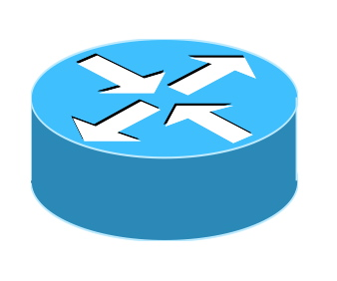
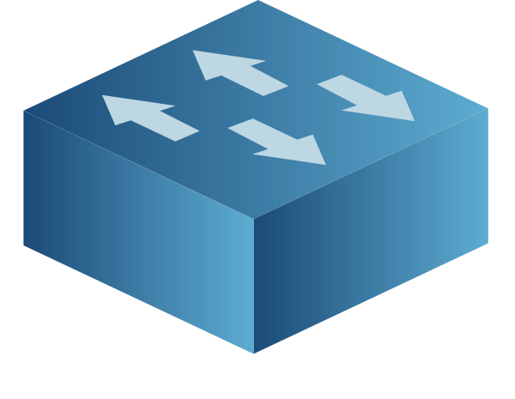
  - switches: Switch: There are many different types of LANs that connect devices on the network, but the network uses the 2960-24TT.

  - Cables: connect everything. The computer and the switch are connected by a straight copper cable. The router is connected with a DTE serial cable.

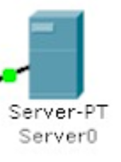
  - server: Server: Provides the necessary services for the network. I am using virtual servers for DHCP, HTTP, DNS, FTP and mail services.

  - Normal devices : pc, printers, smart devices laptops
- Services to be installed (minimum five services) with proper justification.

  - Configuration of each service
INFO | This is for devices and server  172.16.16.0/27  Subnet Mask: 255.255.255.224  Usable Hosts for each subnet = 30
 | Network Address | Usable Host Range | Broadcast Address
Network1 | 172.16.16.0 | 172.16.16.1 - 172.16.16.30 | 172.16.16.31
Network2 | 172.16.16.32 | 172.16.16.33 - 172.16.16.62 | 172.16.16.63
Network3 | 172.16.16.64 | 172.16.16.65 - 172.16.16.94 | 172.16.16.95
Network4 | 172.16.16.96 | 172.16.16.97 - 172.16.16.126 | 172.16.16.127
Network5 | 172.16.16.128 | 172.16.16.129 - 172.16.16.158 | 172.16.16.159
Network6 | 172.16.16.160 | 172.16.16.161 - 172.16.16.190 | 172.16.16.191
Network7 | 172.16.16.192 | 172.16.16.193 - 172.16.16.222 | 172.16.16.223
Network8/server | 172.16.16.224 | 172.16.16.225 - 172.16.16.254 | 172.16.16.255

INFO | Used for RIP V2 between the routers  50.0.0.0/30  Subnet Mask: 255.255.255.252
 | Network Address | Usable Host Range | Broadcast Address
Network 1 | 50.0.0.0 | 50.0.0.1 - 50.0.0.2 | 50.0.0.3
Network 2 | 50.0.0.4 | 50.0.0.5 - 50.0.0.6 | 50.0.0.7
Network 3 | 50.0.0.8 | 50.0.0.9 - 50.0.0.10 | 50.0.0.11
Network 4 | 50.0.0.12 | 50.0.0.13 - 50.0.0.14 | 50.0.0.15

  - IP address of the server DNS = 172.16.16.225/27
IP address of the server = 172.16.16.226/27
- Produce a detailed test plan (NOT TEST RESULTS) to test the design against the requirements
  - a. What to be tested
    - first of all we need to use the tracert (trance route) command is used to check the hope/jumps from device to device in the network and make sure that the route is correct.
    - We need to use ping to check the delay between devices and how many milliseconds are need for each devices to respond to the other
    - we need to use nslookup to check the configuration of the DNS in the server.
    - FTP is used to transfer files over the network and make sure that the network bandwidth is acceptable.
  - b. Tools or commands used for testing.
    - ping <IP address>
    - nslookup projects.jgames.com.jo
  - c. Expected results.
Test | Testing | Result
DHCP | IP Configuration | Successful
Connection | Ping | Successful
FTP/Mail | FTP Commands / Email | Successful
HTTP/DNS | Web Browsing | Successful
maintenance schedule
this maintenance schedule applies on base rules such as the server needs to be restarted in the least request time so.
device | Time
Server reboot/DNS server | Weekend midnight 00:00
Routers | Every 3 days at 5:00 AM
Computer | Every day at 10:00 PM
General maintenance only in case of need or new installations | Weekend

- Implement, test, and diagnose networked systems

  - Conduct verification with packet sniffer, Ping, extended ping, trace route, nslookup, telnet, ftp, etc.
  - Record the test results and ana lyse these against expected results.
  - Recommend potential enhancements and investigate what functionalities would allow the networked system to support device growth and the addition of communication devices.
  - Discuss the significance of upgrades and security requirements in your recommendations.
  - Use critical reflection to evaluate own work and justify valid conclusions.
- Future upgradability / security
  - first of all I am going to start by saying that we can install a back up server in multiple defrinfet location so the data can be secured and safe in multiple location, so we can be sure that its safe and not have geolocation worry’s like the data getting destoryed out of natural cauzes.
  - We can add more server’s and more powerful ones with more capabilitys plus we can add a firewall along side UTP unites incase the electicety goes out we can keep funcationing
  - adding a load balancer so we can receive more connections at the same time without having any of the server crashing /going down.
  - We can start using better cables like fiber cables in side the company by adding the necessary hardware to the computers and laptops so they can use fiber technologies in the line of day to day work which will result in increasing the band width when using the local network and it would be very useful when using the FTP ad FTPS
  - we can install wireless access points that support 5G 6Th gen so the wireless devices can access a faster network.
  - we can add more devices to the company such as printers and computer.
  - we can upgrade the printers to take more load per minute.
  - We can add a VPN connection to the servers so we get more security when connecting to the main servers.
- What I have done
  - it all starts with knowing the limitation that are required from the company, and they are that each network should be able to take 22 devices at maximum plus printers and all the offices but the data center which is in Amman, have WiFi connection ,and the servers must be in the data center.
  - So on those bases the network was build with cost and functionaliy in mind, and by that I shall start with the router which are configured on RIP v2 so they would keep each other updated on the network bases and connections with having much extra delay
  - and each router is conncted to a swtich as the main entranse point in each office building and they can all connect to the main servers in the data center and can use the network to transfer files and connect to other office
  - the servers are connected on a static IP system so other devices would be able to connect to the main server without having any problems because the ip is static
  - and the servers provide DHCP service for all of the other offices in including the data center
  - plus the server contains Email service / DNS service /Ftp service
  - in the ofices all of the printers have the setup od DHCP because OS in the computers can detect the printer on DHCP setup
- analyse against expected results.
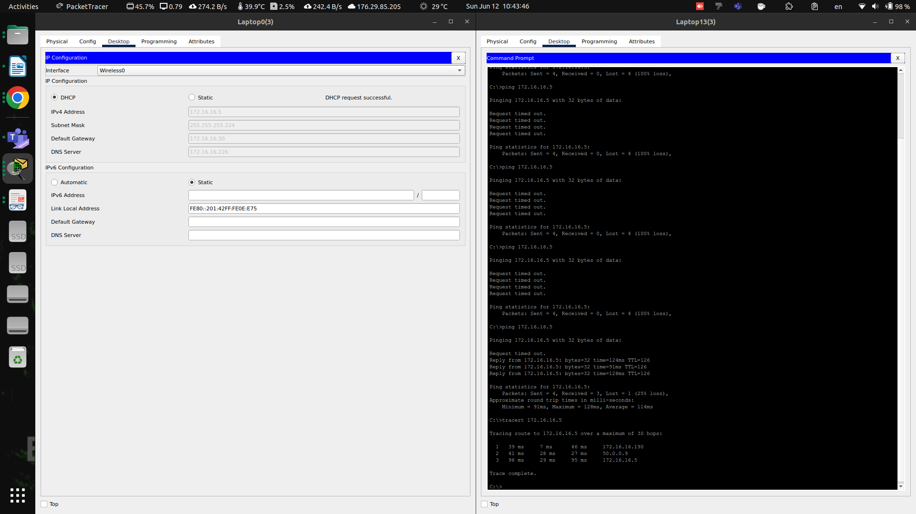
  - All of the sevices should be connected to each other and we should be able to let ping each other to check if they are connected.
And this is the test that was preformed and the result is that it was able to ping the other device over the network in a deffrent office
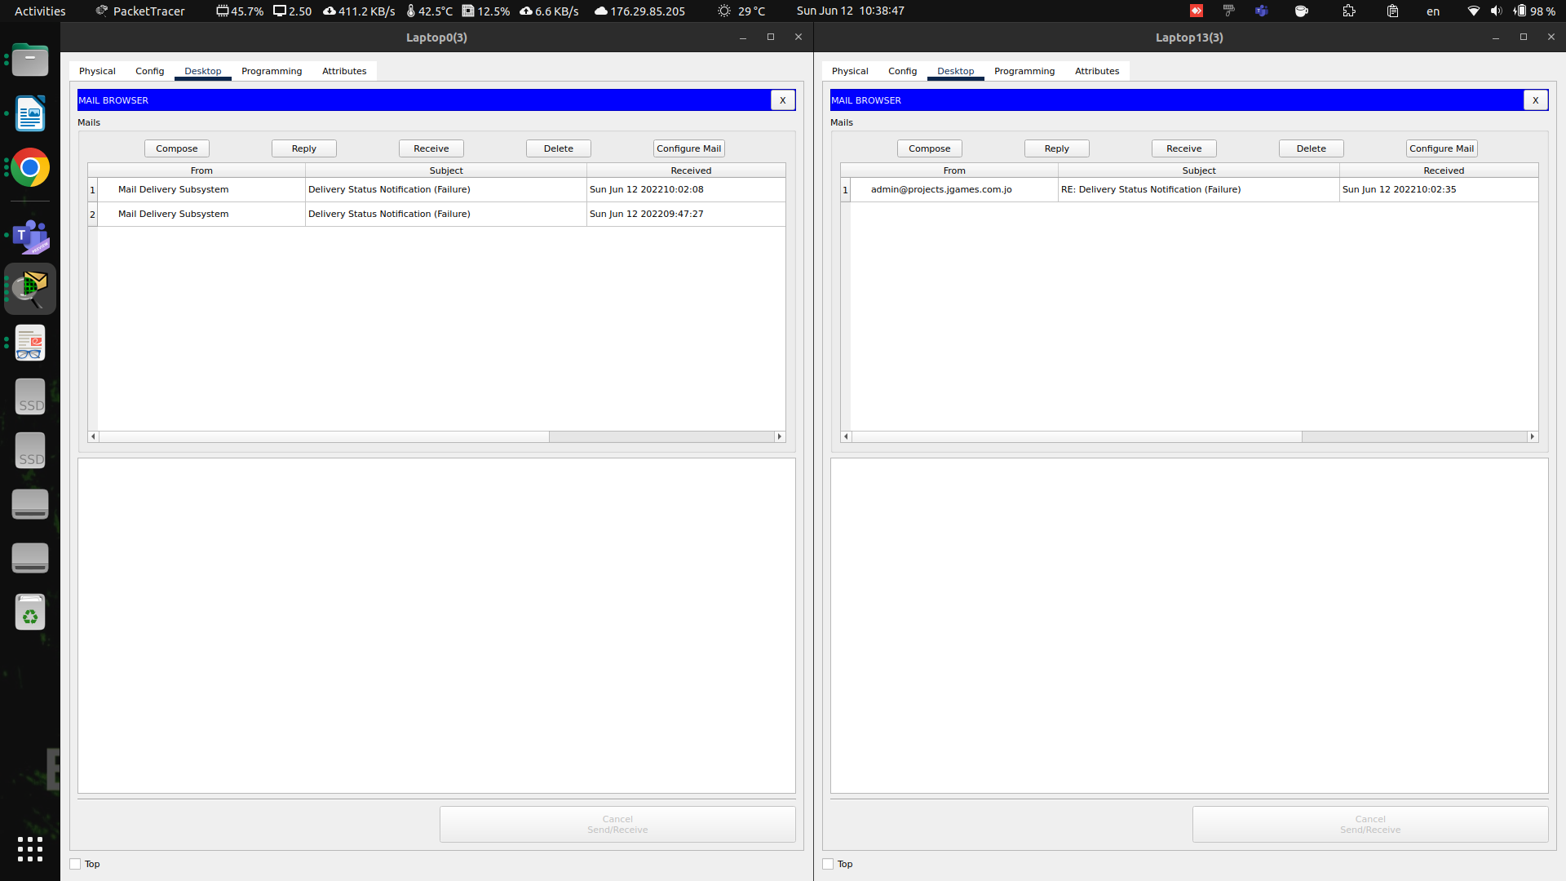
  - all of the company’s employees should be able to use mail service during work times plus it must be easy to access, so in the server, I confugured POP3 and SMTP services so it would enable Email usage in the company.
The result’s show that mail services is used from both sides of the devices by using SMTP and POP3 method’s to communicate between the mail server and the computer’s in the offices.
  - When having a connection between 2 devices in a network we use trace route to figure out what jumps are happening while the connection is being used,
to make sure that jumps are correct and the delay is set to minimum
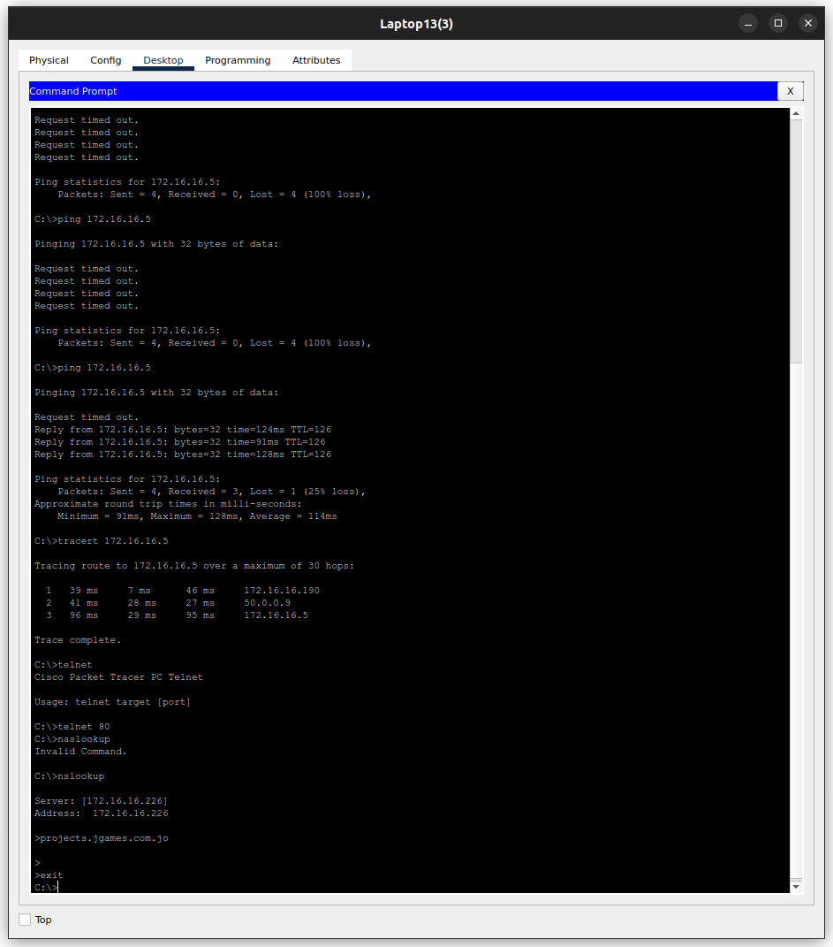
  - when we have a website , we automatically expect to have a DNS record prebuilt/made so it would be easy to access the website and be memorable to the employees , and in this case we used a server for DNS so the employees in the company can have access tot he website without getting in to the complexity of writing a IP addresses to reach the website.
And we test that DNS server IP by using the command nslookup so it can return the IP address for the server and make sure the setup is correct with out having any errors or problems and it was shown the test that it was successful
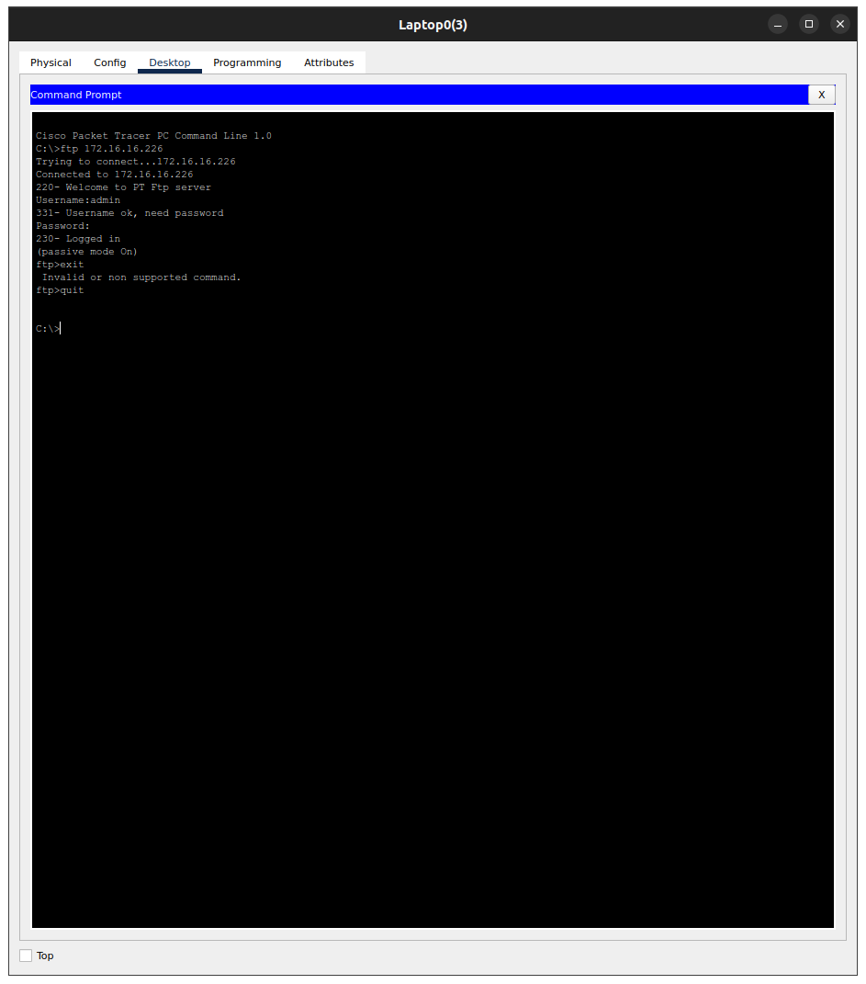
  - in this company using FTP is requested and needs to be implemented, so I setup the server to be able to use FTP service to send files and be able to transfer them between computers and the server
and we tested that by loging in to the FTP service that exists in the server

references

Anonym (2015). Network Server Types Explained. [online] Pittsburgh. Available at: https://www.nhpittsburgh.com/solutions/resources/upcoming-events-and-webinars/network-server-types-explained.
beta.computer-networking.info. (n.d.). Computer Networking : Principles, Protocols and Practice, third edition — Computer Networking : Principles, Protocols and Practice. [online] Available at: https://beta.computer-networking.info/syllabus/default/index.html.
Bourgeois, S. (2016). Network-types. [online] belden.com. Available at: https://www.belden.com/blogs/network-types.
Cabinet Office (2016). Network principles. [online] GOV.UK. Available at: https://www.gov.uk/government/publications/network-principles/network-principles.
Circuit by Unify. (n.d.). Support FAQs: Circuit by Unify. [online] Available at: https://www.circuit.com/unifyportalfaqdetail?articleId=36901.
Cisco. (2019). Using the Extended ping and Extended traceroute Commands. [online] Available at: https://www.cisco.com/c/en/us/support/docs/ip/routing-information-protocol-rip/13730-ext-ping-trace.html.
communications@manageengine.com, M. (n.d.). Network Monitoring Software by ManageEngine OpManager. [online] ManageEngine OpManager. Available at: https://www.manageengine.com.au/network-monitoring/network-protocols.html.
ComputerNetworkingNotes (2018). Network Cable Types and Specifications. [online] ComputerNetworkingNotes. Available at: https://www.computernetworkingnotes.com/networking-tutorials/network-cable-types-and-specifications.html.
Contributor, S. (2019). What is network topology? Best guide to types & diagrams - dnsstuff. [online] DNSstuff. Available at: https://www.dnsstuff.com/what-is-network-topology.
Default. (2019). Network Protocol Definition | Computer Protocol | CompTIA. [online] Available at: https://www.comptia.org/content/guides/what-is-a-network-protocol.
docs.cxengage.net. (n.d.). Bandwidth Availability and Requirements. [online] Available at: https://docs.cxengage.net/Help/Content/Configuration/SystemRequirements/Bandwidth_availability_requirements.htm [Accessed 8 Sep. 2021].
docs.oracle.com. (n.d.). Quality of Service Requirements (Sun Java Enterprise System Deployment Planning Guide). [online] Available at: https://docs.oracle.com/cd/E19636-01/819-2326/gaxqg/index.html.
Indeed Career Guide. (n.d.). Types of Computer Servers and How They Function. [online] Available at: https://www.indeed.com/career-advice/career-development/types-of-servers.
Information Technology at Sonoma State University. (2018). Workstation Hardware & Software. [online] Available at: https://it.sonoma.edu/kb/computers-software-devices/workstation-hardware-software.
Melnick, J. (2019). Network Devices Explained. [online] Netwrix.com. Available at: https://blog.netwrix.com/2019/01/08/network-devices-explained/.
Networks Training. (2020). 8 Different Types of Servers in Computer Networks. [online] Available at: https://www.networkstraining.com/different-types-of-servers/.
Sciencedirect.com. (2009). Bandwidth Requirement - an overview | ScienceDirect Topics. [online] Available at: https://www.sciencedirect.com/topics/computer-science/bandwidth-requirement.
Siegler, M. (2018). 4 Types of Bandwidth: Advantages and Disadvantages - Ecessa. [online] Ecessa. Available at: https://www.ecessa.com/blog/4-types-of-bandwidth-advantages-and-disadvantages/.
Warren, P. (2005). Ten steps to secure networking. [online] Computerworld. Available at: https://www.computerworld.com/article/2559866/ten-steps-to-secure-networking.html.

